SESSION 14
Chi-Square Test
Assignment Notes with Worked Demo
Topics covered: Goodness of Fit | Test of Independence | Contingency Tables | Demo: Contingency Table for Gender vs Product Preference

1. Introduction to the Chi-Square Test
The chi-square (χ²) test is used for categorical data, that is, data that fall into categories such as gender, product choice or region. Instead of comparing means, it compares observed counts with the counts we would expect if some hypothesis were true.
χ² = Σ (O − E)² / E
Here O is the observed frequency in a category and E is the expected frequency. The statistic is zero when observed and expected counts agree exactly, and grows as they differ. Large values of χ² give evidence against H₀.

1.1 The chi-square distribution
- It is right-skewed and takes only non-negative values.
- Its shape depends on the degrees of freedom (df); it becomes more symmetric as df grows.
- The tests are right-tailed: we reject H₀ only when χ² is large.

1.2 Conditions
- Data are counts (frequencies), not percentages or averages.
- Observations are independent, and each falls into exactly one category.
- The sample is random, and every expected count is at least 5 (a common rule). If not, combine categories or use Fisher’s exact test for 2 × 2 tables.

1.3 Two main uses
Test | Question | Data
Goodness of fit | Does one categorical variable follow a claimed distribution? | One variable, observed counts
Independence | Are two categorical variables related? | Two variables, a contingency table

2. Goodness-of-Fit Test
Tests whether the observed distribution of a single categorical variable matches an expected (hypothesized) distribution.
Hypotheses: H₀: the data follow the specified distribution. H₁: the data do not follow the specified distribution.
Eᵢ = n × pᵢ, χ² = Σ (Oᵢ − Eᵢ)² / Eᵢ, df = k − 1
where k is the number of categories and pᵢ is the hypothesized proportion for category i.

Example
Problem: A cafe believes its customers choose four coffee types in the ratio 40% : 30% : 20% : 10%. In a sample of 200 customers the choices were 70, 62, 44 and 24. Test at α = 0.05 whether the belief is supported.
Coffee type | Observed O | Expected E | (O − E)² / E
Type 1 | 70 | 80 | 100 / 80 = 1.250
Type 2 | 62 | 60 | 4 / 60 = 0.067
Type 3 | 44 | 40 | 16 / 40 = 0.400
Type 4 | 24 | 20 | 16 / 20 = 0.800
Total | 200 | 200 | χ² = 2.517

df = 4 − 1 = 3. The critical value at α = 0.05 is 7.815 and the p-value is 0.472.
Decision: Since χ² = 2.517 is less than 7.815 (p = 0.472 > 0.05), we fail to reject H₀. The sample is consistent with the claimed 40:30:20:10 pattern.

3. Contingency Tables and the Test of Independence

3.1 Contingency table
A contingency table (cross-tabulation) displays the joint frequencies of two categorical variables. Rows show the categories of one variable and columns show the categories of the other; each cell holds the count of observations in that combination. The row totals, column totals and grand total are called the marginal totals.

3.2 Test of independence
Hypotheses: H₀: the two variables are independent (no association). H₁: the two variables are associated (not independent).
If the variables are independent, the expected count for each cell is based on the marginal totals:
E = (Row total × Column total) / Grand total
χ² = Σ (O − E)² / E, df = (r − 1)(c − 1)
where r is the number of rows and c is the number of columns.

3.3 Useful follow-up measures
- Standardised residual: (O − E) / √E for each cell. Values beyond about ±2 show which cells drive the association.
- Cramér’s V: V = √[ χ² / (n × min(r − 1, c − 1)) ] measures the strength of association from 0 (none) to 1 (perfect).
- Row percentages: show how the distribution of one variable differs across the categories of the other.

4. Demo: Contingency Table for Gender vs Product Preference

4.1 Problem statement
A company surveyed 200 customers and recorded each customer’s gender and preferred product (Product A, B or C). Build a contingency table and test whether product preference depends on gender. The survey data are illustrative for this demo.

4.2 Step 1: Build the contingency table
Each survey response is one record (gender, preference). Counting the records in each combination gives the contingency table.
Gender | Product A | Product B | Product C | Total
Female | 30 | 40 | 30 | 100
Male | 50 | 30 | 20 | 100
Total | 80 | 70 | 50 | 200

4.3 Step 2: Row percentages
Gender | Product A | Product B | Product C | Total
Female | 30.0% | 40.0% | 30.0% | 100%
Male | 50.0% | 30.0% | 20.0% | 100%
All customers | 40.0% | 35.0% | 25.0% | 100%

Half of the men prefer Product A, against 30% of the women, while women are more likely to prefer Products B and C. The next steps test whether this difference is real or due to chance.

4.4 Step 3: State the hypotheses
- H₀: gender and product preference are independent.
- H₁: gender and product preference are associated.
Significance level: α = 0.05.

4.5 Step 4: Expected counts under independence
For example, the expected number of women preferring Product A = (100 × 80) / 200 = 40.
Gender | Product A | Product B | Product C | Total
Female | 40 | 35 | 25 | 100
Male | 40 | 35 | 25 | 100
Total | 80 | 70 | 50 | 200

All expected counts are at least 5, so the chi-square test is appropriate.

4.6 Step 5: Compute the chi-square statistic
Cell | O | E | (O − E)² / E | Std. residual
Female, A | 30 | 40 | 2.500 | −1.58
Female, B | 40 | 35 | 0.714 | 0.85
Female, C | 30 | 25 | 1.000 | 1.00
Male, A | 50 | 40 | 2.500 | 1.58
Male, B | 30 | 35 | 0.714 | −0.85
Male, C | 20 | 25 | 1.000 | −1.00
Total | 200 | 200 | χ² = 8.429

χ² = 2.500 + 0.714 + 1.000 + 2.500 + 0.714 + 1.000 = 8.429
df = (2 − 1)(3 − 1) = 2

4.7 Step 6: Decision
Quantity | Value | Comparison
Test statistic χ² | 8.429 | Critical value 5.991
p-value | 0.0148 | Less than α = 0.05
Cramér’s V | 0.205 | Small to moderate association
Decision | Reject H₀ | χ² > 5.991 and p < 0.05

4.8 Python code to reproduce the demo
import pandas as pd
from scipy import stats

# Raw survey records (one row per customer)
rows = [('Male','Product A')]*50 + [('Male','Product B')]*30 + [('Male','Product C')]*20
rows += [('Female','Product A')]*30 + [('Female','Product B')]*40 + [('Female','Product C')]*30
df = pd.DataFrame(rows, columns=['Gender', 'Preference'])

# Step 1: contingency table with totals
print(pd.crosstab(df.Gender, df.Preference, margins=True, margins_name='Total'))

# Step 2: chi-square test of independence
table = pd.crosstab(df.Gender, df.Preference)
chi2, p, dof, expected = stats.chi2_contingency(table, correction=False)
print(chi2, p, dof)
print(expected)

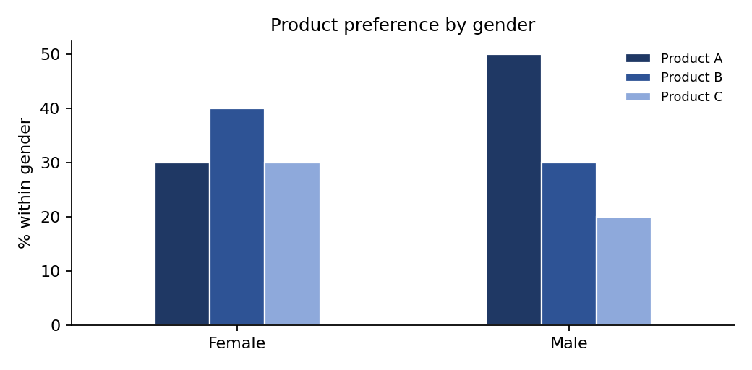
Figure 1: Product preference by gender (percentage within each gender)

4.9 Conclusion
Since χ² = 8.429 exceeds the critical value 5.991 (p = 0.0148 < 0.05), we reject H₀. At the 5% significance level there is sufficient evidence that product preference is associated with gender. Men prefer Product A more than expected (50 observed against 40 expected), while women prefer it less (30 against 40). The strength of the association is small to moderate (Cramér’s V = 0.205).
Note: The test shows an association, not the reason for it. No individual standardised residual exceeds ±2, so the pattern comes from the combined differences across the table rather than a single cell. The business could use this to tailor marketing, for example by promoting Product A more to male customers.

5. Formula Cheat Sheet
Concept | Formula
Chi-square statistic | χ² = Σ (O − E)² / E
Goodness of fit: expected | Eᵢ = n × pᵢ, df = k − 1
Independence: expected | E = (Row total × Column total) / Grand total
Independence: df | df = (r − 1)(c − 1)
Standardised residual | (O − E) / √E
Cramér’s V | V = √[ χ² / (n × min(r − 1, c − 1)) ]
Decision rule | Reject H₀ if χ² > critical value (or p ≤ α)

